🚀 Thrilled to Share My Latest AI Adventure: Building a Powerful AI Agent Suite with CrewAI and FastMCP! 🚀
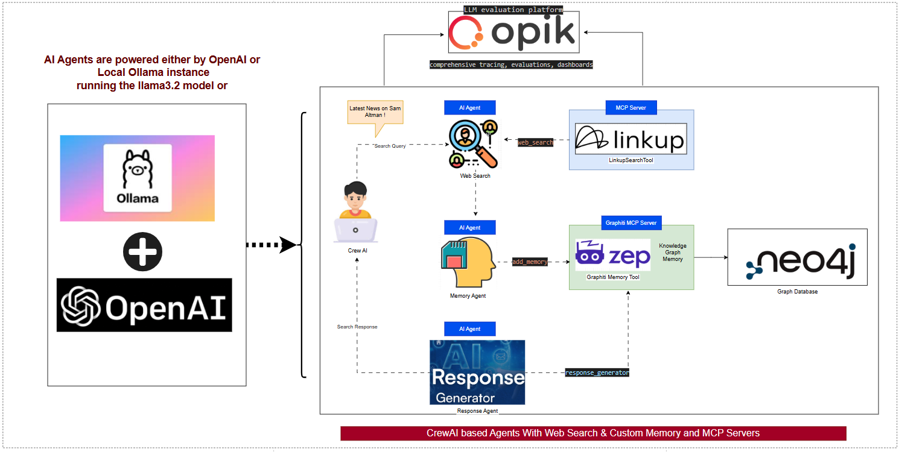
Hey LinkedIn fam! I've been diving deep into the world of AI agents, and I'm excited to showcase my recent project: a cutting-edge suite of AI Agents designed to supercharge web search, memory management, and intelligent response generation. This isn't just code—it's a symphony of AI orchestration that's pushing boundaries! 🌟
First off, a quick shoutout to CrewAI—the open-source framework that's revolutionizing multi-agent systems. In just a few lines: CrewAI lets you create collaborative AI agents that work together like a dream team, handling complex tasks autonomously with seamless integration of LLMs, tools, and workflows. It's flexible, scalable, and perfect for building intelligent systems that mimic human-like collaboration. If you're into AI orchestration, CrewAI is a game-changer!
At the heart of my suite are three powerhouse AI Agents:
- Web Search Agent: Hunts down real-time info from the web like a digital detective.
- Memory Storage Agent: Safeguards and retrieves knowledge with lightning speed.
- Response Generator Agent: Crafts smart, context-aware replies that feel truly human.
These agents are powered by OpenAI for cloud-based muscle or a local Ollama instance for privacy-focused, on-device magic—giving you the best of both worlds! 💡
But wait, the real magic happens with two MCP Servers by FastMCP:
- Linkup-powered MCP Server: Enables seamless tool integration and web search capabilities.
- Graphiti-powered MCP Server: Handles agent memory like a pro, ensuring nothing gets forgotten.
I leveraged an arsenal of top-tier tools to make this suite robust and efficient:
- Opik for LLM evaluation and tracing—keeping everything performant and debuggable.
- LinkupSearchTool for lightning-fast web searches.
- MCP Server for effortless tool integration across agents.
- Graphiti MCP Server for advanced agent memory management.
- Zep as the knowledge-based graph for structured data handling.
- Graphiti (Zep’s open-source graph engine) for building dynamic graphs.
- Neo4J Database for rock-solid graph storage and querying.

This setup isn't just functional—it's a blueprint for scalable AI solutions that can tackle real-world challenges head-on. Whether it's research, customer support, or creative brainstorming, these agents are ready to level up your workflow!
Entire code is accessible here with multiple Readme.md👇
https://github.com/arunmanglick-code/codetogether/tree/main/Arun.Manglick.AIMLDL/04_Build_AI_Agents/01_AgentBuild_Using_CrewAI
#AIAgents #CrewAI #FastMCP #OpenAI #Ollama #AIInnovation #MachineLearning

